School Council
Expression of Interest (EOI)
Outside School Hours Care (OSHC) service at
BRIAGOLONG PRIMARY SCHOOL

Reference Number: | BPS1117
Submission Details:
Closing Time: | 4pm – Friday October 1st, 2021
Place of Lodgement: | All EOI submissions must be
Receiving Staff Member: | provided via email and received at the following email address before the Closing Date and Time:  Briagolong.ps@education.vic.gov.au  Mark Donald
Additional Details: | OSHC Grant applied for to begin service in 2022.  Third Party OSHC Providers are invited to complete an EOI to deliver an OSHC service at Briagolong Primary School as part of the DET OSHC Establishment Grant Initiative. The EOI form is provided on the school website and must be submitted no late than 4pm on October 1st, 2021.  www.briagps.vic.edu.au

Submissions must follow the format attached, including the completion of all Forms, plus supporting documentation and any additional requested information.

CONDITIONS
- EOI Presentations
Briagolong Primary School (“the School”) does not warrant the accuracy of the content of the EOI. The School will not be liable for any omission from the EOI document.
- Confidentiality
The School may require persons and organisations wishing to access or obtain a copy of this EOI (or information relevant to this EOI) to execute a deed of confidentiality in a form required by, or satisfactory to, the School before or after access is granted.
Whether or not execution of a deed of confidentiality is required by the School, all persons obtaining or receiving this EOI and any other information in connection with the EOI must keep the contents of the EOI and such other information confidential and not disclose or use that information except as required for the purpose of developing a response to this EOI.
- EOI Documents
All responses to the EOI and any accompanying documents will, upon submission, become the property of the School. The School will not return any of these documents.
By submitting a response to this EOI, the service provider licenses the School to reproduce the whole or any portion of the documents which it has submitted for the purposes of, or in connection with, its evaluation, notwithstanding any copyright or other intellectual property rights that may subsist in those documents.
- Enquiries
Enquiries concerning the EOI must be made to the following Contact Person:
Name: Mark Donald
Title: Principal
E-mail: Briagolong.ps@education.vic.gov.au
Phone: 5145 5260 (please email for after hours / holiday contact number)
All enquiries concerning the EOI must be in writing and can only be made up to three (3) days prior to the Closing Time.
The School will respond to enquiries correctly lodged in accordance with the above conditions in writing and the response from the School will be provided to all parties that have requested a copy of the EOI document.
Should a service provider contact any person other than the Contact Person nominated above (including but not limited to: any parents and School Council member or office bearer, employee, school employee, departmental officer or an employee of the current provider) in regards to this EOI, it may be disqualified from the EOI process and may be ineligible for consideration.
- Late EOI
If an EOI is lodged after the Closing Time, it may be disqualified from the EOI process and may be ineligible for consideration unless:
- The service provider can clearly document to the satisfaction of the School that an event of exceptional circumstances caused the EOI to be lodged after the Closing Time; and
- The School is satisfied that accepting a late submission would not compromise the integrity of the process.
The determination of the School as to the actual time that the service provider’s response is lodged is final. All EOIs lodged after the Closing Time will be recorded by the School. The School will inform service providers whose EOI was lodged after the Closing Time of their ineligibility for consideration.
- Incomplete EOIs
If an EOI does not include all the information in the format required by the EOI or is incomplete in any way as determined by the School in its sole discretion, it may be rejected.
- Validity of EOIs
An EOI will be valid for acceptance by the School for a period of 90 business days from the Closing Time. This period may be extended by mutual agreement between the parties.
- Supplier Code of Conduct
Bidders are required to meet or exceed the government’s supplier code of conduct - http://www.procurement.vic.gov.au/Suppliers/Supplier-Code-of-Conduct
- Unauthorised Communication and Improper Assistance
Service providers are required to direct all communications through the Contact Person, unless advised otherwise by the Contact Person or the School. Unauthorised communication and/or seeking to obtain assistance of employees, agents or contractors of the School in preparation of their proposal may, in the absolute discretion of the School, lead to disqualification of an EOI submission.
- Reservation
The School reserves the right to, in its absolute discretion, refuse to consider or accept any EOI or all EOIs. The School will not necessarily accept the lowest priced EOI nor any other EOI. The School further reserves the right to:
- Reject all EOIs without giving reason for the rejection; and
- Accept a portion or the whole of any EOI at the price or prices quoted unless the EOI states specifically to the contrary.
- Negotiate with one or more service providers and allow any service provider to vary its EOI.

- Preferred service provider
Selection as a preferred service provider does not give rise to a contract (express or implied) between the preferred supplier and the School Council for the supply of Services. No legal relationship will exist between the School and the preferred supplier until such time as a binding agreement is executed by both parties.

- Conflict of Interest
When submitting its submission, the service provider must declare any actual or potential conflicts of interest which may arise between the service provider and the School or the School and any subcontractor which the service provider proposes to engage in respect of the supply of Services.

EOI DETAILS

- Background
Briagolong Primary School is in the Gippsland (Wellington) Region which services a small residential area and surrounding community of Briagolong approximately 35km from Sale. The school has a current enrolment of 87 students in years Prep to Grade 6. It is expected that enrolment will increase to 95 to 100 students over the next 2 years.

Physical features of the school include 5 classrooms, a Library, Mudbrick Building, Office, Kitchen and Staffroom. There are 2 playgrounds, 2 ovals, 1 full size basketball court, an undercover area and ample outdoor space that includes a sensory and vegetable gardens.

The student population, assumed to be represented by a wide range of socio-economic backgrounds, is likely to be characterised by a reasonable percentage of families with both parents working.

The Outside School Hours Care (OSHC) Service is required to cater for the following approximate number of children of school age during both Victorian term periods and vacation periods.

    - Before School numbers: Less than 10 (Service By Negotiation)
    - After School numbers: 20+
    - Student Free Day numbers: Service By Negotiation
    - Vacation Care numbers: Service By Negotiation
    - Early school finishes/ End of term early finishes: 20+

Site visit: The Principal of Briagolong Primary School offers prospective providers an opportunity to view the school OSHC facilities between October 18 and November 1 between 9am and 5pm. Alternative dates may be negotiated. All visits will adhere strictly to the school’s covid safe plan. Service providers are required to advise the Contact Person of their intention to attend by close of business October 15. No more than two (2) attendees from the same service provider may attend the same site visit. All attendees must sign the attendance record which will be provided at each site visit.

A current OSHC Service does not exist at the school.

Facilities available for use by the successful service provider to deliver the services required include the Mudbrick Building, Kitchen and areas around the school grounds including both playgrounds, the undercover area, both ovals and basketball court. There are 2 ovals and 2 playgrounds. Equipment available for use include sporting equipment, board games, kitchen utensils and other requested items.

The School wishes to advise that currently the following practices occur that may impact on the numbers attending the service: Community Hall activities (not frequent). Alternative arrangements and key events affecting OSHC provision will be captured in the memorandum of understanding developed in partnership with the preferred provider.

Further information regarding OSHC in schools can be found at:

www.education.vic.gov.au/school/teachers/management/Pages/oshc.aspx

- Scope
Length of Service:
To provide Outside School Hours Care to the School community for a 2 year contract with an option for a 1 extension.

Required Operating Hours:
- Before school care: By Negotiation
- After school care – 3:15pm to 6:00pm
- Vacation care – By Negotiation
- Early school finishes/ End of term Early finishes – 2:15pm to 6pm

The provider will be allowed access to the space 30 minutes before and 30 minutes after the required operating hours to provide opportunity to set up and pack up the area for OSHC use.

School Council statement:
The School Council wants the OSHC to provide an education and care service to the school community.

The School Council believe that OSHC should be a place for growth, nurture and building long-term life skills.

The School Council believe that all employees that work in the OSHC service should be facilitators of positive development who provide a safe, engaging environment and intentionally support positive social, emotional, logical thinking, moral, and life skills development; that they teach social skills and nurture healthy interactions.

The School Council believe children should have the opportunity to:
- Engage in play and leisure activities.
- Learn new skills to further their development.
- Be safe and supervised at all times.
- Build relationships with educators in a community which is connected to but separate from the school community.
- Develop as happy, healthy and resilient individuals.
- Engage in indoor and outdoor play activities planned with and for the children.
- Participate in a range of developmentally appropriate options that cater for the needs and interests of all children including construction, drama, dress-ups, art and craft, cooking, quiet reading and games.
- Experiences and programs delivered by external educators and organisations coming into the service such as language, performing arts, sports etc.

The School will license the following facilities:
- Outdoor ovals / basketball courts and playgrounds.
- Undercover area, sensory garden and vegetable garden.
- Toilets (M/F) for both staff and students.
- Mudbrick Building and Kitchen
- Library and Office
- 1 indoor classroom with direct external access.
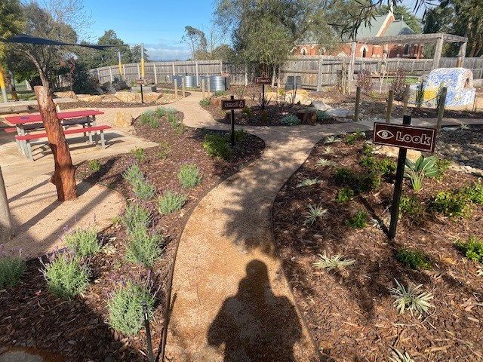
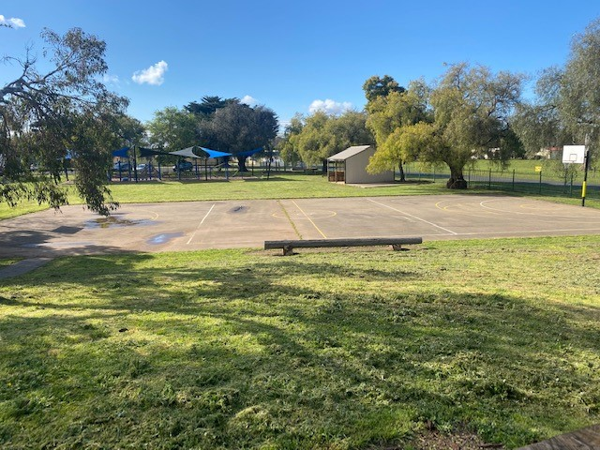
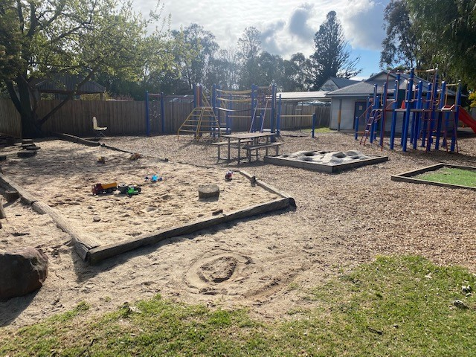
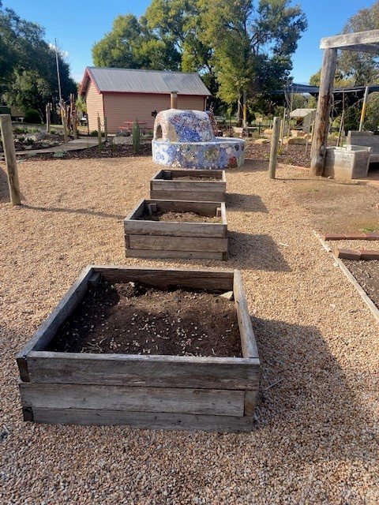
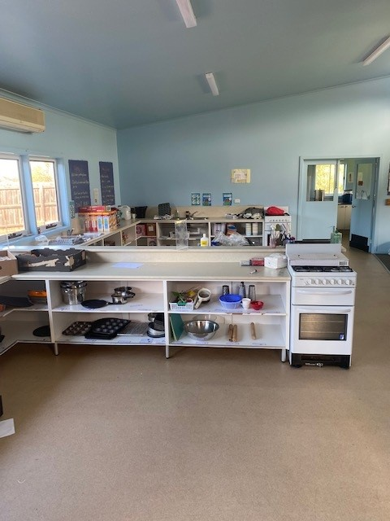
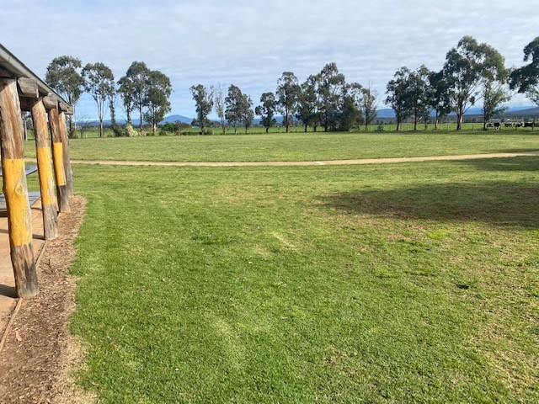
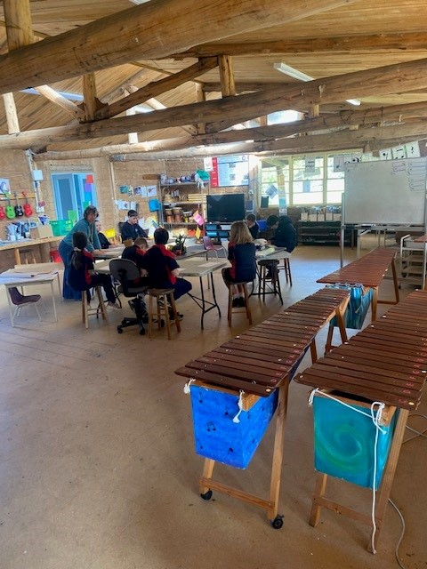

Required regulatory compliance:
It is the responsibility of the selected service provider to comply with the National Law and National Regulations at all times. Any updates or changes to the facilities to meet these requirements will be the cost/ responsibility of the service provider. Particular attention should be paid to the following:
- 3.25 square metres of unencumbered indoor space per child (r.107)
- 7 square metres of unencumbered outdoor space per child (or additional unencumbered indoor space with approval of the Victorian regulatory authority) (r.108)
- outdoor spaces must provide adequate shade and allow children to explore the natural environment (r.113—4)
- the availability of areas that can be used to support children to rest if needed (r.81)
- the accessibility of toilets (r.109)
- the provision of adequate heating/cooling, ventilation and natural light (r.110)
- the availability of administration space and space for conducting private conversations (r.111)
- whether the area promotes visibility and facilitates effective supervision (r.115)
- the cleanliness and safety of the premises, furniture and equipment (r.103)
- prescribed information required to be displayed (r.173)

Child Safe Standards:
As of 2016, all early childhood services (including OSHC) and schools are required to comply with Child Safe Standards; they include seven standards designed to ensure organisations that work with children take steps to create a culture of child safety and protect children from all forms of abuse. The standards are as follows:
- Strategies to embed an organisational culture of child safety
- A child safe policy or statement of commitment to child safety
- A child safety code of conduct
- Screening, supervision, training and other human resources practices that reduce the risk of child abuse
- Procedures for responding to and reporting suspected child abuse
- Strategies to identify and reduce or remove risks of child abuse
- Strategies to promote child participation and empowerment

Capability of provider:
A person’s capability to operate an education and care service is of critical importance. Updates in the national law as of 2017 have been identified to address this through specifying:
- Either the approved provider, a nominated supervisor, or a Person in day to day charge must be present when a service is operating
- Services will be able to have more than one nominated supervisor
- The approved provider will be responsible for ensuring the person they appoint as a nominated supervisor must be fit and proper and have suitable skills to supervise the service
- A nominated supervisor will need to consent in writing to appointment to the role
- Each nominated supervisor and person in day to day charge will have to undertake child protection training

The service provider must advise as part of the EOI submission how they have implemented, operate and comply with the Child Safe Standards.

Food and drink:
The successful service provider will be required to provide food and drink to students as a part of the OSHC Service. Equipment available for the provision of food and drinks include plates, bowls, cups, cutlery, utensils and cooking facilities.
Any food and drink supplied must be nutritious, in adequate quantity and take into account the child’s growth and developmental needs and cultural, religious and health requirements (r.79). An accurate weekly menu must also be displayed (r.80).

Cleaning
The service provider is expected to do a general tidy and wipe down of tables and equipment after a session. The school will engage its main cleaner to do full scale cleaning of the area. A memorandum of understanding wil be created with the preferred provider.

Maintenance / Repairs:
Any maintenance or repairs required, beyond reasonable wear and tear, must be prepared by the service provider. If these are not rectified in a timely way, the School Council may do so, and any costs will be invoiced direct to the service provider.

Transition / Implementation Plan:
The successful service provider, if not the incumbent, is required to provide a transition plan, which includes but is not limited to an outline of the hand over process, appropriate handling of children details and data, removal of the outgoing service provider’s equipment and cleaning/maintenance requirements.

Referees:
Service providers are required to nominate three (3) customers (preferably schools) to whom they currently provide similar services. The School reserves the right to also contact known customers of the service provider to seek customer feedback. Feedback will be sought in respect of, but not limited to, the service provider’s performance, charges, responsiveness and complaint resolution.
- Important Dates
- School site visit date(s): N/A
- EOI Closing date: Friday October 1st at 4pm
- EOI proposals shortlisted by: Friday 8th October
- ​Shortlisted service providers invited to present to School Council:Via Webex – Date by Negotiation
- Extraordinary meeting of School Council:​ Monday 11th October
- Decision made regarding preferred service provider: After grant is announced
- ​Preferred service provider informed of decision and beginning of contract negotiations: After grant is announced
- Commencement of service to the School: 28th January 2022

- Reporting and meeting requirements
The service provider’s representative is required to meet, where requested, with a nominated representative, School Council or subcommittee once per quarter to review vacancies, complaints and waiting lists, at a minimum.

The service provider will be required to report to a nominated representative, School Council or subcommittee as follows:

Quarterly on the following items
- National Quality Standard (NQS) assessment and rating reports provided by regulatory authority, relevant to the service
- Any breaches or non-compliance with the National Quality Framework (NQF) requirements
- Programming changes
- Staffing
- Policy changes
- Incidents
- All complaints received, and action taken to resolve complaints and timeframe for resolution
- Service usage and vacancies
- Waiting lists

Within 30 days of commencing, and then on an annual basis a copy of the following:
- NQF Audits
- Current Suitability Notices for all specified employees
- Copies of any new or renewed Insurances

An ad hoc basis, which would be required to be responded to within ten (10) business days:
- Average utilisation rate for each session of education and care provided
- Details of children enrolled in the OSHC Service including their attendance
- Copy of educator rosters
- All complaints received and any action taken to resolve these complaints and the timeframes for resolution
- Child, parent and staff feedback
- Details/results relating of any National Quality Framework audit conducted in connection with the OSHC Service

Report the following within two business days:
- Incidents, injuries or issues that have impacted in the health, safety or wellbeing of any child
- Occupational health and safety matters
- Any Formal Compliance Directive issued to the Licensee by the Regulatory Authority in connection with the OSHC Service
- Where the service provider has been charged with a criminal of regulatory matter, found guilt by court, cautioned, or otherwise pursued by either the Police, Local Authority or other regulatory body or subject to enforcement activity.

Report any instances where the service provided, in relation to the licensed premises, have been assessed and rated as Significant Improvement Required under the National Quality Framework within five business days.

A report prior to the commencement of any new specified personnel detailing name, contact details and a copy of the Working with Children Check.

Upon occurrence immediately report:
- Damage to or an accident in the licensed area
- Any notice or report received in relation to the licensed area, and provide a copy of the report

Key Performance Indicators (KPIs)

KPI | Performance Target
NQF Rating | NQF ratings to remain at Meeting or Exceeding the National Quality Standard (NQS) for all 7 quality areas.
User Satisfaction | 85% of children users to respond either at or above expected satisfaction levels based on a satisfaction survey, if requested by School Council.
Customer Service | 85% of adult users to respond either at or above expected satisfaction levels. This would be based on a survey devised in consultation with the School Council.
Reporting | 100% of reports to School Council are delivered within the nominated timeframes.

Submissions must address the service provider’s provision of quality management systems and key KPIs used to track the performance of the contract.
- Licence Fees & Amounts Payable
If applicable, the successful service provider will be required to pay the following Licence Fee:
$1.00 per year
Licence fees will be payable annually in advance.
Licence fees will be reviewed annually, prior to the anniversary of the contract.
The successful service provider will be required to pay a security deposit of $1.00 prior to commencement of the service.
- Insurance
Minimum insurances the service provider are required to hold include:

- Public Liability Insurance
$10 million per event.
- Property Insurance
Insurance cover for the reinstatement or replacement value of the Licensees’ own property against the destruction of or damage of such property which is housed, stored, kept or used in or at the Licensed Area.
- WorkCover Insurance
Insurance in accordance with the requirements of the Accident Compensation Act 1985 (Vic) and the Accident Compensation (Work Cover Insurance) Act 1993 (Vic) which provide the Associates of the service provider (including equivalent cover for volunteers) with cover against personal injury or sickness arising from provided goods or services or working in or on the Licenced Area.

- Selection Criteria
The selection criteria for rating responses received from service providers are as follows:

- Quality:
      - Demonstrated experience as an approved provider of OSHC service(s). This may include evidence of overall assessment and rating(s) against the National Quality Standard of at least Meeting for similar service(s) operated by the approved provider.
      - Demonstrated ability to plan, deliver and monitor an education program that reflects the needs and values of a school community.
      - Commitment to the appointment and retention of suitably qualified staff and their ongoing professional development.
      - Demonstrated knowledge and understanding of the process to develop a Quality Improvement Plan and ensure continuous improvement.

- Value for money:
      - A proposed fee structure that offers value for money for families and allows all children to participate.
      - A proposed fee structure that considers how all children may participate in activities that incur an additional cost.
      - A transparent process for revising fees, including those for cancellations and late pick-up fees.
      - A proposed licence fee that provides good value to the school community and gives a clear outline of all costs that may fall to School Council. This may include any income shortfall situations, advertising, utilities and maintenance.

- Financial viability:
      - The provider must be financially viable and have the capacity to apply sufficient financial and other resources to a new service.

- Policies and processes:
      - Demonstrated experience in engaging families in the policies and programs of an OSHC service.
      - Demonstrated commitment to enacting polices and processes that reflect the needs and values of a school community.
      - Demonstrated understanding of compliance and regulatory requirements in operating an OSHC service and commitment to Child Safe Standards.

- Information sharing:
      - Commitment to the information sharing detailed in the Department of Education and Training’s OSHC Licence Agreement.

​The above selection criteria are not presented in any particular order or ranking.

- Contract Documentation
The successful service provider will be required to enter into an agreement with the School Council under the terms and conditions of the DET OSHC Licence Agreement, as attached to this EOI.

Special conditions may be included subject to the agreement of the School Council.
FORM 1 – COMPANY DETAILS

Attached is the Expression of Interest of:
Business / Corporation / Person:
(Businesses list all proprietors)
Postal Address:
Street / Physical Address:
Australian Business Number (ABN): | ABN:  OR  - Will you be applying for an ABN?  Yes No (mark appropriate box)
Is it proposed to sub-contract any part of the Goods and/or Services?  If “YES”, specify full name and address of each sub-contractor and their relevant experience and expertise in relation to the offered Goods and/or Services | Yes No (mark appropriate box)
Size | Small Medium Large Not for profit  (mark appropriate box)  Note: Small to Medium Enterprises (SMEs) are defined as firms with less than 200 full time equivalent employees. Under 20 full time equivalent employees is defined as Small, 20-199 full time equivalent employees is defined as Medium and 200 plus full time equivalent employees is defined as Large.
Supplier Diversity Status | Indigenous Business Disability Enterprise  Social Enterprise Not Applicable Other:__________________  (mark appropriate box)  Note: Please include copies of relevant documentation to support your Supplier Diversity Status
Contact Name, Phone and Fax No:
Contact email address:
Authorised Signature(s):
Name(s):
Date:

FORM 2 – SPECIFICATION STATEMENT

Please provide a written statement including:

- How you are best placed to meet the scope
- Details of your knowledge and previous experience in delivery of OSHC
- Details of your knowledge, resources and systems that will enhance the delivery of the OSHC service
- Any value added services, such as innovation, operating above staff ratio

FORM 3 – OFFER REQUIREMENTS
- Does your organisation understand and agree to provide the OSHC Services during the Hours of Operation outlined below:

Yes No

Period | Start Time | Finish Time
After School Care | <<00:00>>PM | <<00:00>>PM
Vacation Care | <<00:00>>AM | <<00:00>>PM
Early school finishes/ end of term finishes | <<00:00>>AM | <<00:00>>PM

Hours of Operation cannot be varied without agreement in writing from a nominated representative and relevant regulatory approvals.

(if alternative hours of care are proposed, please attach details)
Response:

- Does your organisation understand and agree that the proposed Commencement Date for the OSHC Service is 28th January, 2022.
NOTE: This date is proposed only and the exact commencement date will be agreed to by the school and any successful service provider and may depend on time taken to receive Site Licensing Approval.

Yes No

- Does your organisation currently have provider approval to operate an OSHC service?

Yes No

Please attach proof of this approval to the EOI response.

- Has your organisation made full disclosure of all fees and charges in the Form 6 - Pricing Schedule?

Yes No

If No Response:

5. Does your organisation currently have the financial capacity to deliver the service?

Yes No

Please provide details of your organisation’s financial capability, such as a credit check, or steps that will be taken to improve the financial capability:

FORM 4 – HIGH QUALITY OSHC SERVICE
- Please provide information on the education program you plan to offer (r. 75)

1a. Please provide a copy of the approved learning framework for the service.

1b. Service providers are to provide a sample of a routine five (5) day program for one calendar week (Monday to Friday) for both Before and After School Care and a five (5) day sample program for Vacation Care (if applicable), highlighting the diversity and quality of the activities and inclusive of the consideration of students with a disability or special needs.
1c. Service providers are also to address their approach to the following:
- Delivery of the educational program
- Staffing of the program and staff
- Review/ customisation of the program
- Approach to inclusion of all children

Response:

Has your organisation attached the sample programs?

Yes No

- Provide details of quality resources/play equipment available to support the programs being provided for use at the school site. Include a detailed list of both, resources and equipment as well as the estimated dollar value of resources and equipment.

Response:

- Please identify how your organisation has implemented and compiles with the Child Safe Standards?

Response:

- Service providers are required to provide details of how they will continue to strive for an improvement in services at the nominated site in order to achieve higher ratings awarded by the National Quality Framework Audits?

4a. Provide a sample Quality Improvement Plan (Maximum 5 pages)

Response:

- Provide details of all services associated with Approved Provider’s individual Service Assessment and Ratings under the National Quality Framework (NQF). Provide the overall service rating(s).

Response:

Number of Services currently operated in Victoria
Number of Services that have been assessed while you were the approved provider under NQF
Number of Services yet to be assessed under NQF

Number of Services with each rating while you were the approved provider

Exceeding National Quality Standard (NQS)
Meeting NQS
Working towards NQS
Significant improvement required to meet NQS

- Detail below the enrolment numbers that your organisation considers to be the minimum number required to ensure a viable OSHC Service can be provided at this school.

Response:

Service Provided | Minimum Enrolments
Before School Care
After School Care
Student Free Days
Vacation Care
Early school finishes/ end of term finishes

6a. Please detail how you would manage an increase in size.

- Provide details on how children and families will benefit should your organisation be selected as the successful service provider.

Response:

- Provide your complaints process, including escalation procedure.

Response:

- Please provide copies of the following forms/documents as part of your response, as they relate to The National Law and National Regulations.
- Incident, injury, trauma and illness record forms (r.87)
- Medication record forms (r.92)
- Emergency and evacuation plans (r.97)
- Attendance and enrolment record forms (r.158-162)
- Policies and procedures (r.168 and r.171)
- Storage of records policy (r.183, and as set out in r.177)
- Law and regulations that will be accessible at the service (r.185)

Response:

FORM 5 – QUALITY PERSONNEL AND PROCESS
- Provide details of how you will recruit the staff required for the service and timeframe involved?

Response:

Add cross-referenced attachment if required.

- Provide details of your proposed team information for the delivery of the OSHC Service for this Site. This information should include:
- Detail titles, roles, responsibilities, qualifications and experiences for each title listed.
- Identify the names of the personnel you plan to put forward and relevant qualifications (if applicable).
- Identify which roles you plan to recruit staff for.
- Outline how you intend to meet the capability requirements as outlined in the scope.
- Any use of temp or agency staff

Response:

2a. Does your organisation agree that all relevant personnel will hold appropriate accreditations and qualifications in terms of National Quality Framework for Early Childhood Education and Care and comply with the National Law and National Regulations, prior to commencement of employment at this Outside School Hours Care service?

Yes No

If “No”, Provide Details:

2b. Please indicate if you will provide, one month prior to commencement of services if selected, the names, qualifications, and a photocopy of the Working with Children Check or the receipt of application and contact details for all specified personnel.

Yes No

- Provide information on your organisation’s process regarding the following:
- Enrolments
- Bookings
- Payments

Payment in arrears  (end users are able to pay for services after attendance) | Yes No
Payment in advance  (end users are required to pay for services prior to attendance) | Yes No

Accepted payment methods:
Direct debit | Yes No
Cash | Yes No
Cheque | Yes No
Money order | Yes No
Credit card | Yes No
BPay | Yes No
Other (please specify): | Yes No
If Yes, advise any Surcharge Fee(s) that apply (e.g. Credit Cards) _________________

Response:

Add cross-referenced attachment if required.

- Please advise whether the nominated facilities identified in the scope provide sufficient space for you to operate a service with the estimated numbers provided.

Response:

FORM 6 – PRICING SCHEDULE
All amounts quoted are to be exclusive of GST. Prices are not to include rebates or discount structures.

Please also include information on the process for setting and revising fees.

Licence fees
 | 2022
Before School Care | Regular | $
 | Late Booking | $
After School Care | Regular | $
 | Late Booking | $
Student Free Day | Regular | $
 | Late Booking | $
Holiday Program / Vacation Care | Regular | $
 | Late Booking | $
Late collection Fees  (If fees apply, detail how these are calculated). | Late collection | $

With regard to other fees chargeable table below, the School would not expect these increase beyond CPI for each subsequent year of the contract.

Other Fees Chargeable |  | Fee Amount |  | Provide details
Enrolment, Membership or Application fee (please indicate)
Absence Fee (advice of the absence is received)  Please indicate whether the normal session fee would be charged and if a penalty charge is applied or if there is no charge applicable. |  | Session Fee | Penalty Fee
Absence Fee (No notification of a child’s absence from the service)  Please indicate whether the normal session fee would be charged and if a penalty charge is applied |  | Session Fee | Penalty Fee
Any other fees/charges (expand table as required)
This is to include any charges applicable to payment of accounts
Please provide information regarding incursions provided by your organisation including the type of incursions available, fees and cancellation policy.
Please provide details of any situations where fees are adjusted, e.g.: siblings
Please provide information regarding excursions provided by your organisation including the type of excursions available, fees and cancellation policy.

FORM 7 – CONFLICT OF INTEREST DECLARATION

I / We, _______________________________ make the following declaration of any actual or perceived conflict of interest, including but not limited to any pecuniary or other interests in Briagolong Primary School or any relationships our staff and office bearers have with Briagolong Primary School management, staff and/or School Council members.

Name (print)

Signed:

Date:

FORM 8 - REFEREES

- Where possible, provide details of up to three (3) customers (preferably schools) to which your organisation has/is provided/providing a similar Service. NOTE: These schools MAY be contacted to verify past/present performances.

ORGANISATION | CONTACT PERSON | CONTACT NUMBER | EMAIL ADDRESS

